Victoria 162 – Pre-race Reminders and updates賽前提示
Live Tracking Link : Click Here
- Weather Update
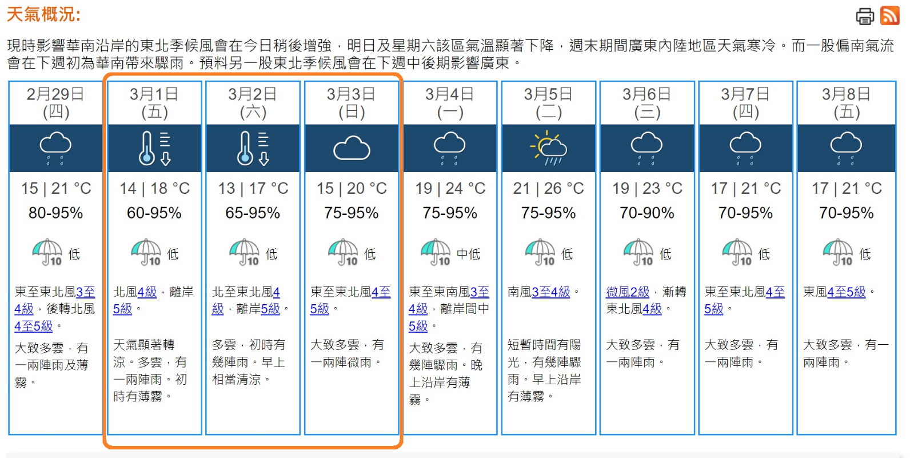
The weather during Mar 1 – Mar 3 will be very cool, overcast and a few showers. Saturday’s lowest would be 13’C, and on high grounds this would mean less than 10’C. Please dress accordingly, stay dry, and for 3-day runners, please make sure you have a warm enough sleeping gear with you to ensure a comfortable sleep in the tents, and not be exposed to the cold west weather.
Visit https://www.hko.gov.hk/tc/wxinfo/currwx/fnd.htm for latest weather update.

3月1日至3日天氣顯著轉涼，大致多雲，每日預計有一兩陣雨。星期六最低氣溫為13度，山區高地將更低至約10度或以下。請按需要調整比賽衣服及裝備，保持乾爽，三日賽跑手亦應備有足夠保暖的睡袋，以確保您可在大會帳篷渡過寒夜，安然入眠。
按以上連結參考香港天文台最新預測。

- L57 / 3-day / V162 Starting Area – slight move across the bridge
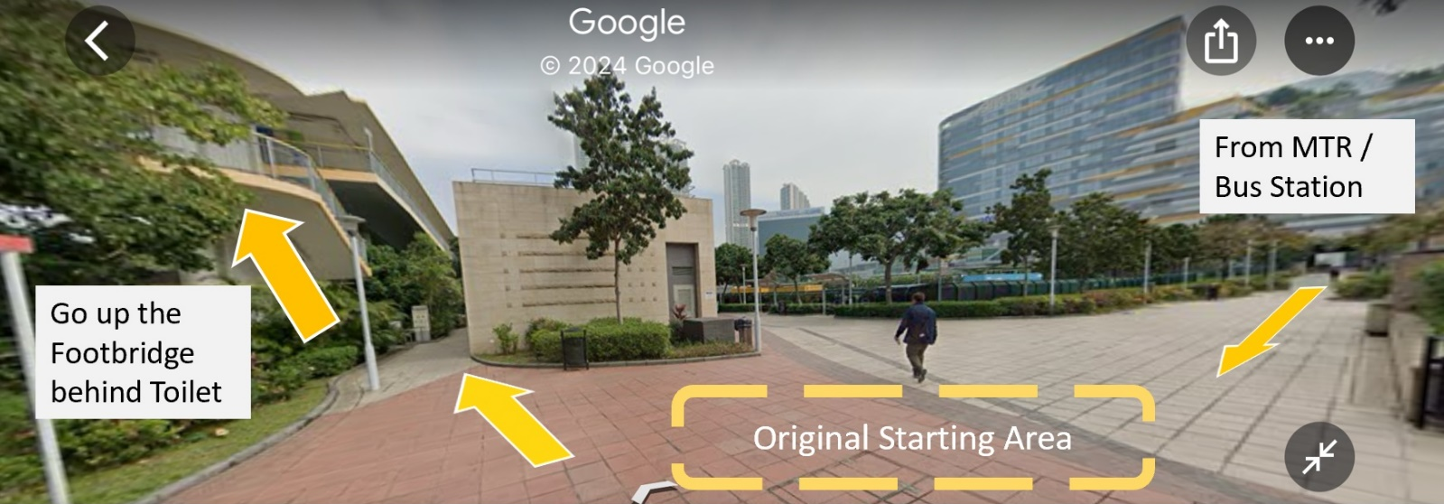
Due to an unscheduled construction work, we have to move the L57 / 3-day / Victoria 162 starting area at Tat Tung Road Garden by 150 meters, to the seashore promenade across the bridge. Please look for signage once you reached Tat Tung Road Garden, go up the stairs and cross the bridge. The area would be at the other side of the footbridge.

因為場地維修工程，起點位置將往北移150米， 一橋之隔的海濱長廊。到達東路花園後，請跟指示在公廁後方上樓梯過橋，起點就在橋的另一面。

- Food List
Latest Food List can be found here, please hit refresh in browser to see latest version.
最新食物清單已上戴。
https://www.victoria162.hk/food-list

- Luggage Drop-off at start / Pick up at End point
All races except V162 – Drop off at start point with your luggage tag to be picked up at end point. Upon check-in, please scan QR code at counter to record your dropped luggage time and bib number. Pick up simply with your bib and we will mark on the back of your bib .
V162 – Drop off your N5 drop bag and end point luggage at start point. QR code record applies. After using your drop bag at N5, it will be transported to end point to be picked up together with your luggage.

所有賽事 (除V162 外) – 起點使用大會行李牌作行李寄存，行李將運往終點。在寄存時，請掃描行李站的QR code以紀錄賽號及寄存時間。終點領取時只需出示號碼布便可，大會人員會劃上記號以示已取。
V162 – 在起點寄存N5中繼包及終點行李。寄存時亦需使用QR code紀錄。中繼包用完後將運往終點，與行李一同領取。

- Mandatory Gear
We reserve the right to perform gear check at any check points including end point. Failing gear check will result in disqualification Please see link to the mandatory gear.
Gear check for 3-day race and challenge will be performed before starting each day.

大會可在檢查站及終點抽查任何跑手的強制裝備，如未能通過將會取消資格。強制裝備清單在此。
3日賽/3日挑戰賽每日出發前均會進行裝備檢查。
https://www.victoria162.hk/mandatory-gear

- V162 MTR connection / Overnight Bus connection
For V162 mandatory MTR transit during MTR operating hours, paid by Octupus, transit guide please click here .

For N10 – H0, if you arrive at N10 during MTR stoppage hours of 1am-6am, and do not have a taxi or car to cross harbour, CP staff will guide you to the Tunnel bus stop right outside of N10, and ride 1 station to Island Place bus stop. Once get off, follow A3 Signage to reach H0 which is about 750m away along the tram tracks. Runners can also source own transportation (taxi, friend's support etc) ONLY during MTR stoppage hours.

25mins for transit from L5 to N0 and 20mins from N10 to H0 would be automatically deducted for ALL runners regardless of actual time spent.

過海交通必需以港鐵接駁, 跑手需以現金或八達通支付. 按此 看接駁指南.

N10 – H0 於港鐵停止營運期間, 可於N10 油塘背後的東隧巴士站乘坐N巴士 (N619/N680/N691) 一站, 往港運城下車後，跟賽會指示步行約十分鐘到 H0．跑手亦可自行乘坐其他如的士或朋友接載等交通工具過海，此安排只適用於港鐵停運期間.

所有跑手於過海期間, 不論實際車程需時, 將統一在比賽時間內由L5至N0扣除25分鐘, 及由N10至H0 扣除20分鐘之乘車時間.

